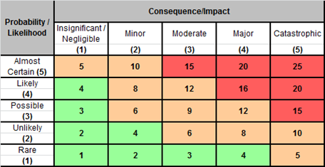
VARM Risk Management Plan:
INSERT NAME OF ADULT
DOB:
Address:
Unique VARM ID #:
Date of meeting:

The Risk | Potential Consequences of the Risk | RAG Score | Actions to Mitigate Risk  (Include additional resources if required) | By whom | By When

Triggers for Instigating Review of Plan
Situation | Action to be taken

Agreed date to review plan: |  | Signature of Chair:
 |  | Date:
Signature of Adult (if agreed): |  | Date:

