
WARWICKSHIRE CHILDREN SAFEGUARDING PARTNERSHIP
Practitioner Escalation Policy Briefing
What is Escalation?
Escalation is the formal process of challenging decisions made by other professionals, groups or organisations. Escalation policies and procedures ensure that all professionals have a quick and straightforward means of resolving differences of professional opinion to safeguard the welfare of children and young people.
Where can you access Warwickshire’s policy?
Warwickshire Safeguarding Children Partnership (WSCP) escalation policy is available here.
When to use the Escalation Policy?
The Escalation Policy should be used whenever there are concerns about professional practice, safeguarding decision-making, or resource allocation that may impact the safety or well-being of a child. It applies to all practitioners, whether working in a paid or voluntary capacity.
This policy is designed to support practitioners in understanding the escalation process and feeling confident in knowing when and how to raise concerns constructively.

Examples of when to escalate concerns raised:

- Around a decision for referral from one agency to another; whether the referral should be made or accepted.
- About a Child and Family plan or its implementation
- About an intervention to bring about the necessary changes
- About the outcome of an assessment
- Over the sharing of information and communication in a particular case
- About the position taken by management linked to a specific safeguarding case which remains unresolved

How to use the escalation policy?
Timely and effective resolution of professional challenge is essential to keeping the child’s safety and well-being at the centre of practice. The policy supports open, respectful and restorative conversations, grounded in relationship-based practice.
Professionals are expected to:
- Communicate concerns clearly and respectfully
- Follow the agreed escalation process when issues cannot be resolved at the first point of contact
The policy outlines a 4-stage process with clear timescales, to ensure concerns are addressed promptly and constructively.
The escalation monitoring form supports accountability, tracks progress and resolutions, and captures learning to improve future practice.

WSCP Escalation Process Flowchart
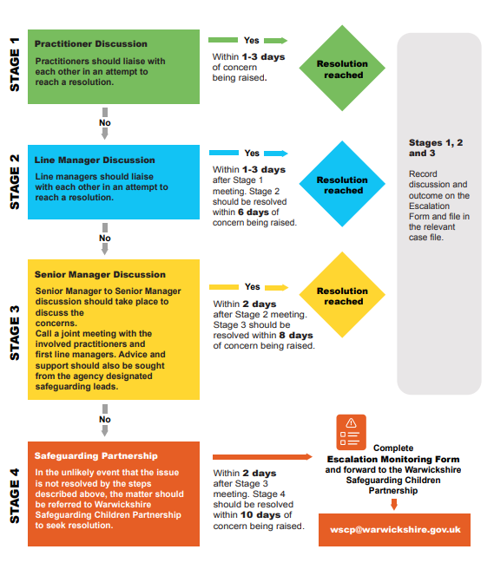

REMEMBER
- Keep an open mind: Always be willing to review decisions and plans, always prioritising the welfare of the child and family.
- Record outcomes clearly: Document the discussion and agreed actions in writing and record on the child’s file.
- Communicate promptly: Managers must immediately share agreed actions with staff working directly with the child and family and ensure they are accurately recorded on the child’s file.
- Review and respond: Senior managers should review relevant policies or procedures and address any issues related to compliance or professional competence.
- Follow through: Managers are responsible for ensuring all agreed actions are completed within the set timescales.
Where can I find more information?
Visit the website to read the full Escalation Policy and download the monitoring form.

